**Rex PSet8 Q1**

**Control: Training with 6 epochs @ 0.01 learning rate & 128 Batch Size, Training accuracy = 64.88%**

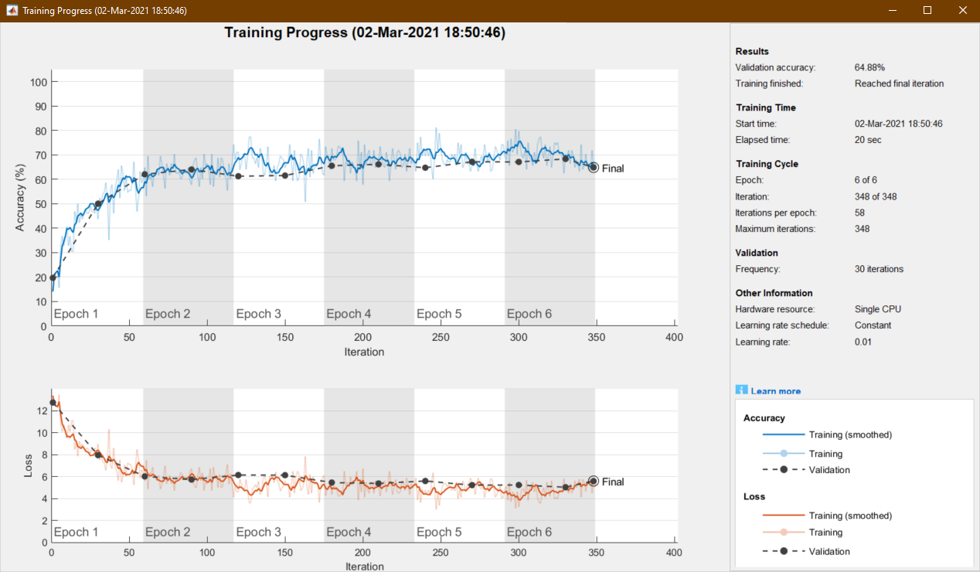

**Modifying Learning Rate:**

Increasing Learning Rate: Training with 6 epochs @0.5 learning rate & 128 Batch Size, Training accuracy = 67.32%

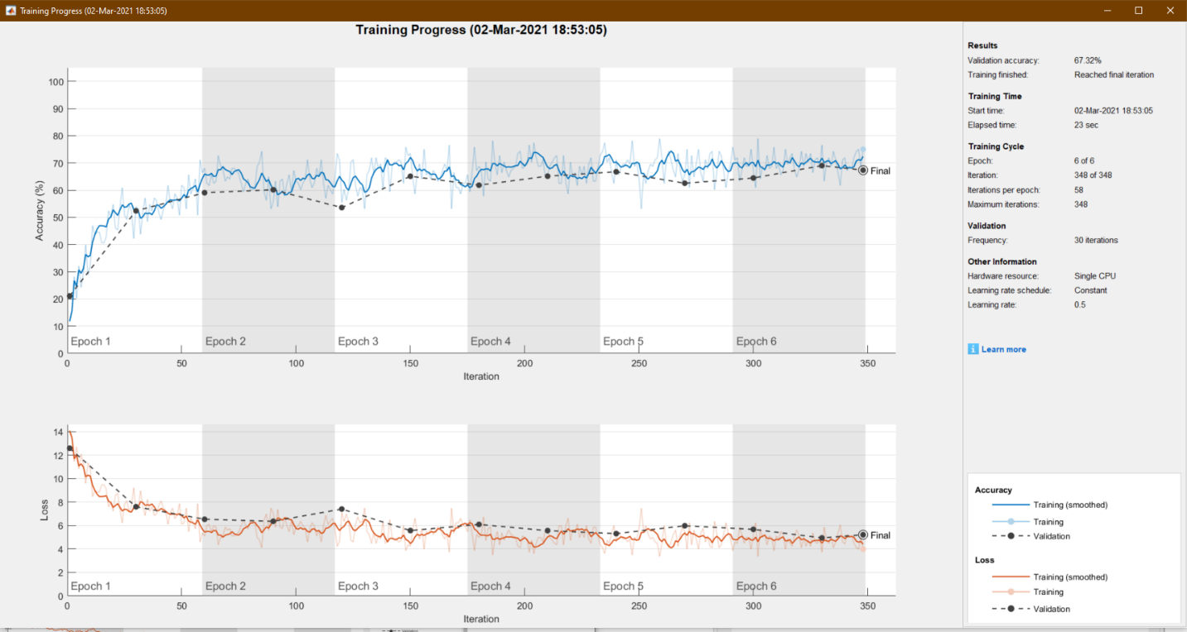

Decreasing Learning Rate: Training with 6 epochs @0.001 learning rate & 128 Batch Size, Training accuracy = 66.92%

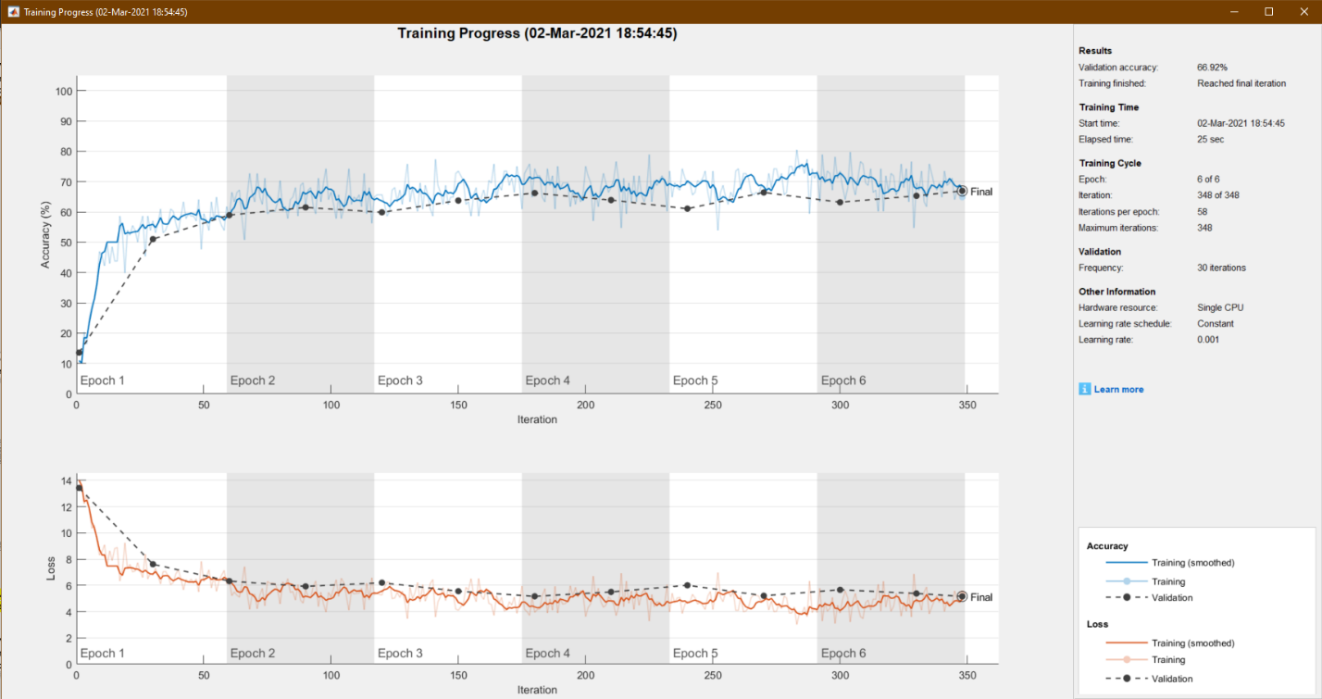

We can conclude from these two training sessions that increasing or decreasing the learning rate does not drastically affect the training accuracy.

**Modifying Batch Size:**

Increasing Batch Size: Training with 6 epochs @0.01 learning rate & 1024 Batch Size, Training accuracy = 65.64%

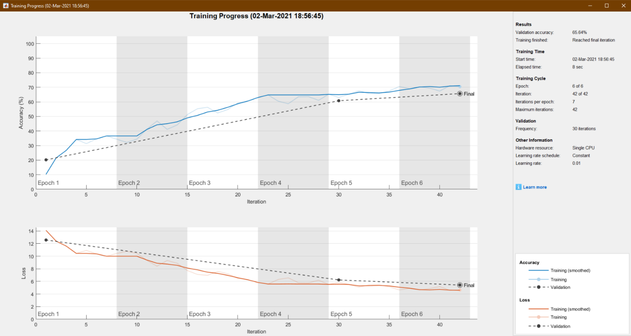

Decreasing Batch Size: Training with 6 epochs @0.01 learning rate & 16 Batch Size, Training accuracy = 65.56%

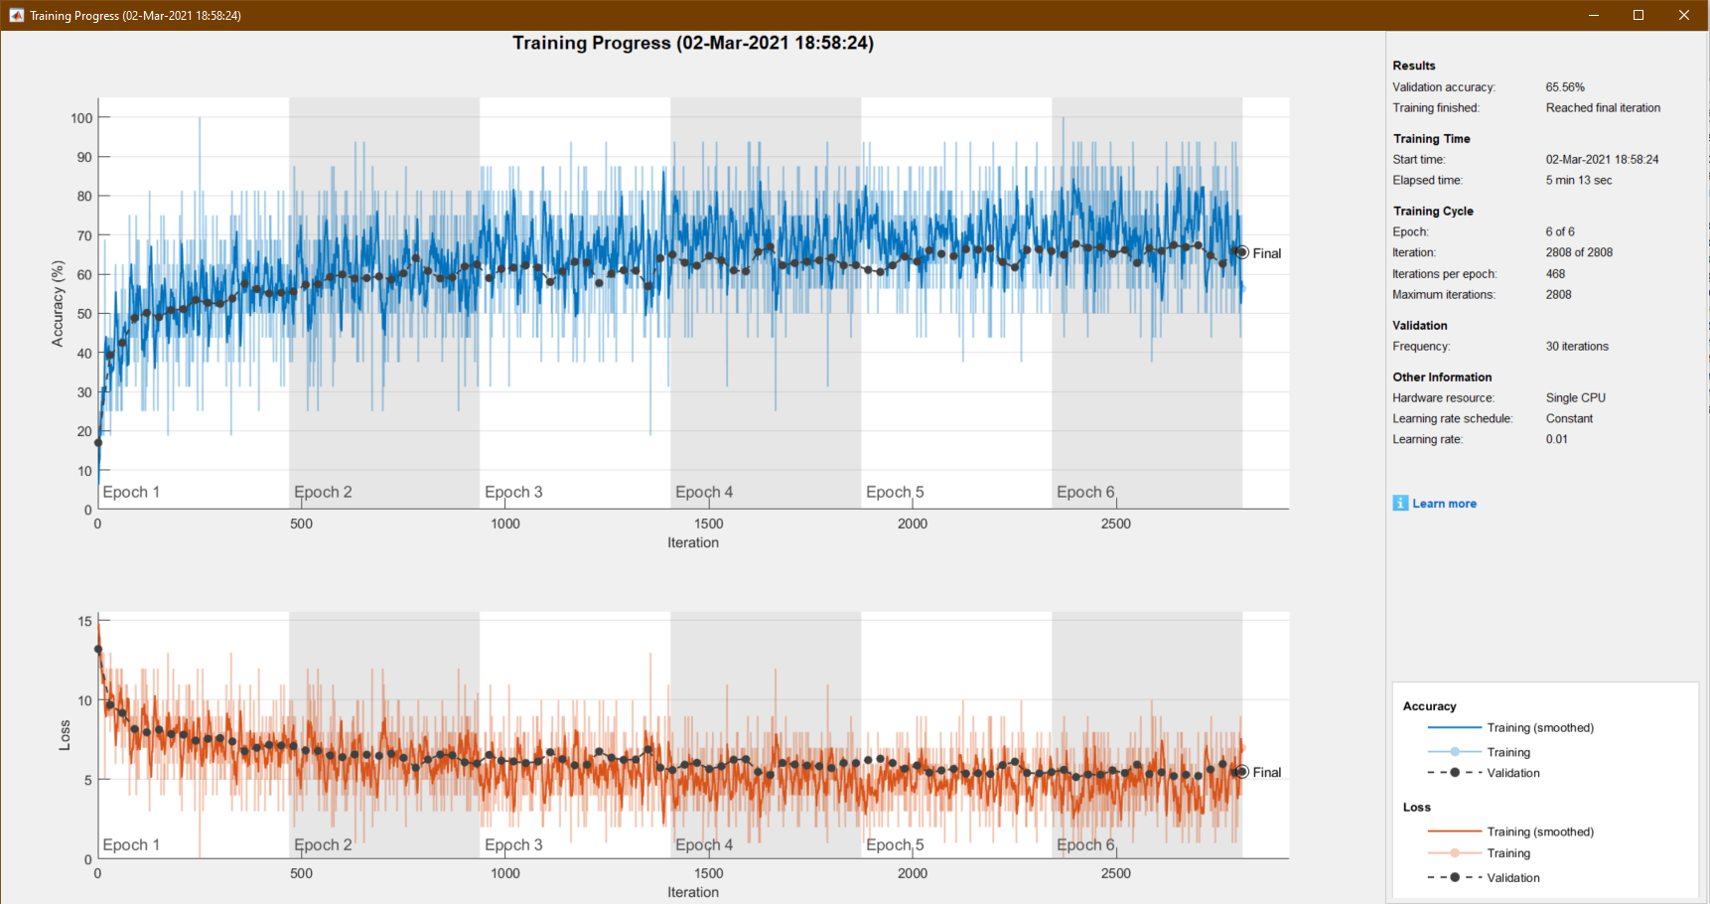

We can conclude from these two training sessions that increasing or decreasing the batch size does not drastically affect the training accuracy either.